JOB DESCRIPTION QUESTIONNAIRE (J.D.Q.)

HMI CATEGORY CODE:
DIRECTORATE: Investigations
AREA/DEPT: PVP / MASH
FAU:
SECTION: VPRU – Vulnerable Persons Referral Unit
JOB TITLE: REFERRAL MANAGER
REPORTS TO: Detective Sergeant VPRU
CURRENT RANK/GRADE: D
DATE: Aug 2018

1. JOB PURPOSE: (Briefly state your job’s overall objectives. To.......................................”)
To manage a team of Referral Assessors and Safeguarding Researchers within the Vulnerable Persons Referral Unit (VPRU), ensuring that all referrals both internal and external regarding vulnerable persons are processed and referred on to partner agencies and manage a support service that researches safeguarding history, and shares relevant information to Police, Local Authorities and other relevant partner agencies for the safeguarding of children and vulnerable adults.

2. PRINCIPAL ACCOUNTABILITIES:
(Describe the important end results you are expected to achieve).

- Manage and support a team of Referral Assessors and Safeguarding Researchers in the VPRU. Provide leadership and guidance to staff to ensure all vulnerability referrals are processed and shared with relevant partners in a timely, sensitive and confidential manner in accordance with current DPA legislation, GDPR, Authorised Professional Practice (APP) on Information Management issued by the College of Policing including Home Office Code of Practice on MOPI, Freedom of Information Act and local information sharing agreements.

- Ensure that all information shared with partner agencies is correctly and accurately recorded by staff in order to comply with legislation, providing a professional and efficient service to partners.

- Ensure workloads are effectively distributed amongst staff, appropriately prioritised, and any issues potentially affecting performance, throughput, or effectiveness of the Unit are identified and raised to the Detective Sergeant VPRU.

- Have oversight of the Blue / Red / Amber / Green (BRAG) process applied by Referral Assessors for rating referrals to ensure appropriate cases are disseminated to Local Authority contact centres to safeguard children. Ensure appropriate referrals are completed to partner agencies such as Social Care, Listening Ear, Operation Encompass, drugs and alcohol services, domestic abuse support agencies and Merseyside Fire and Rescue Service in order to reduce risk to and support children and vulnerable adults.

- Quality assure the Units research and collation of information and safeguarding history on relevant nominals, and provide additional support via force systems to assist Referral Assessors in identifying a person at risk or posing a risk.

- To review nightly reports and utilise appropriate tools such as Delphi, Corvus, Storm and Niche to identify cases where a vulnerability has been identified, but no referral has been received so that officers can be tasked to complete a Vulnerable Persons Referral Form (VPRF), striving for 100% compliance in VPRF submission rates. Manage the “VPRF Compliance List”.

- Proactively support the development and quality assurance of the VPRU. Identify gaps, blockages and good practice and publicise these across all partner agencies in order to improve the provision.

- Ensure that staff are MoPI trained in accordance with the National Learning & Development Strategy and that all responsibilities are undertaken in relation to information management, data quality, and information sharing, intelligence and information security in accordance with the ACPO Guidance on the Management of Police Information in order to comply with the Statutory Code of Practice

3(a) KNOWLEDGE AND EXPERIENCE:
(What kind of knowledge, skills and experience are necessary to enable satisfactory performance in the job and why are they necessary?).

Qualifications and Knowledge

It is essential that the post holder has undertaken training on the Management of Police Information (MOPI) or more recently “Managing Information” as the Unit will be handling and sharing sensitive personal data with external partners, and in supervising the Unit, the post holder will be required to ensure full compliance with Home Office Code of Practice on MOPI, Data Protection Act, General Data Protection Regulation and the Freedom of Information Act.

Knowledge of the parameters of the information sharing framework provided by Statutory Guidance “Working Together to Safeguard Children and Vulnerable Adults (2018)” – also known by the short title as “Working Together 2018”.

Knowledge of the parameters of the various Information Sharing Agreements (ISA’s) between Police and partner agencies that lay out the framework of which information can be shared and under what circumstances.

It is essential that the post holder has undertaken relevant training in the various way of identifying vulnerability across a range of disciplines covering child protection, domestic abuse, mental health and vulnerable adults in order to be able to effectively guide and support staff within the Unit.

Knowledge of Child Protection, Vulnerable Adult and Domestic Abuse processes and best practice, and Authorised Professional Practice (APP) to enable competent decision making and provision of information to Police and partner agencies for safeguarding cases.

Experience

Experience of managing electronic VPRF’s through the Corvus interface, and use of Corvus and Delphi to identify referrals in progress, partially completed referrals, referrals not properly submitted and referrals that have failed in transfer due to IT issues to ensure that no risk remains hidden or lost in the system.

Experience of multi-agency information sharing around safeguarding processes, conducting research on force systems and evaluating safeguarding histories to distil relevant information, and provide clear, balanced and unbiased information to partner agencies which differentiates between fact and opinion.

Experience of assessing vulnerability utilising common risk assessment tools such as MERIT, DASH, “Levels of Need”, “Continuum of Need” etc. is highly desirable.

Experience of working in a business area of high demand and high risk. To demonstrate a record of accurately identifying pertinent information and providing a timely response to enable partner agencies to appropriately manage risk.

Experience of managing staff, addressing welfare needs, and promoting self-development amongst the team via a Personal Development Review process or equivalent, and managing and challenging poor performance.

Skills and Abilities

Must have good communication and inter-personal skills, both written and verbal, to enable the completion of accurate and concise reports for Police and partner agencies whether by email, telephone or face to face meetings, in order to provide an effective service to Police and partner agencies.

Proficiency in using force IT systems such as MS Excel, MS Outlook, MS Power Point, MS Word and the ability to self-improve by gaining on-line learning from NCALT, Breeze and Virtual Training Library in any relevant courses when necessary in order to improve knowledge and skills to provide an effective service to safeguard children and vulnerable adults.

Ability to research and interrogate force systems i.e. NICHE, PNC, PND, CORVUS and STORM in order to collate information relevant to the role on a daily basis. Post holder must also have the ability to learn and use other IT systems (e.g. partner agency systems such as Liquid Logic) to provide an effective inter agency data sharing service.

Possess high levels of self-motivation in order to work in a small team environment, work independently and manage workloads when required, to provide an effective Police service within inter-agency working.

3(b) (Does your post require any Police Powers, and if so what are they, and why are they necessary?)

N/A

4. RELATIONSHIPS:

(a) Supervisory responsibilities:

First Line Manager to a team of 5 x Referral Assessors.
First Line Manager to 1 x Safeguarding Researchers

(b) Supervision Received:

First Line Manager the Detective Sergeant VPRU

Second Line Manager the Detective Inspector VPRU.

Line Managers will be available daily for guidance and support.

Regular supervision and feedback meetings to be arranged by Line Managers.

(c) Other Contacts:

(i) Within Merseyside Police:

Detective Sergeant’s MASH - daily contact
Safeguarding Researchers within MASH strands - daily contact
PVPU investigators - daily contact
Reporting Officers for VPRF’s (LP, R&R, Inv) - as and when needed

All contacts are required to ensure timely sharing of information and advice, to safeguard children and vulnerable adults.

(ii) Outside Merseyside Police:

Safeguarding Partner Agencies – daily contact with all for referral processing
e.g. Social Care – Children and Adult
Health
Education
Probation
IDVA (Independent Domestic Violence Advocate)
IDSVA (Independent Domestic and Sexual Violence Advocate)
IMCA (Independent Mental Capacity Advocate)
Social Housing Providers
Domestic Abuse services (such as LDAS, SLDAS, SWACA)

All contacts are required to ensure timely sharing of information, and advice to be provided, to safeguard vulnerable children and adults.

5. CONTEXT:
(a) Operating Environment: (Services provided, work patterns, who are the customers).

The post holder will manage a team of referral assessors and safeguarding researchers within the VPRU and quality assure their staffs work and performance in relation to their research, collation, dissemination of Police information to multi-agency partners for the purposes of Safeguarding children and vulnerable adults and liaise with Police and partner agencies regarding the progression of risk management and multi-agency case work.

Provide advice and guidance to police and partner agencies as to whether safeguarding referrals are necessary and in what format.

Manage team members ensuring that all have an appropriate workload to complete, which will see daily tasks being achieved.

The post holder will predominantly work a three week shift pattern of standard day shifts that cover 7-days per week, working one weekend in every three weeks, with an equalisation allowance paid accordingly.

(b) Framework and Boundaries: (Policies and procedures which affect you and how these
can be changed).

Merseyside Police Domestic Abuse Policy

Merseyside Police Child Abuse Policy

Merseyside Police Child Sexual Exploitation Policy

Merseyside Police Child Abduction Warning Notice Policy

Merseyside Police Adult at Risk Policy

Working Together 2018 and the Care Act 2014

ECHR Law

Data Protection Act and proposed Data Protection Act 2018, and General Data Protection Regulation (GDPR), MOPI, Freedom Of Information Act, National Decision Making Model, Police Driving Regulations and Merseyside Police Policies and Procedures.

Information Sharing Agreements.

Any internal Police changes that are required can be discussed with Line Managers.

(c) Organisation: (For each type of post that reports directly to you, outline below the posts overall responsibilities).

Referral Assessors – review all vulnerability referrals made to the police (from internal and external sources), assess risk and evaluate the needs of the person referred, to research police systems to gather all known information on the person(s) referred, and to make informed decisions on the appropriate referral pathways and support networks required to ensure that risk is managed and vulnerable adults and children are effectively safeguarded.

Safeguarding Researchers - respond to information sharing requests from police and partner agencies, by researching Police information, distilling relevant and pertinent information into the appropriate format, and sharing it with relevant parties to enable them to put effective safeguarding measures in place to manage risk and reduce harm.

6. DIMENSIONS: (Indicate in quantitative terms, key areas on which your job has an impact).

Financial: N/A

Staff: The post holder will manage 6 staff as first line manager

Other: The number of customers varies on a daily basis but will always include all partner agencies pan Merseyside and departments within Merseyside Police.

The geographic territory is Merseyside Police Force / Local Authority Boundaries.

7. JOB CHALLENGES: (Describe the most challenging or complex parts of your job).

Managing the volume of referrals and demands of information sharing requests across the gamut of partner agencies, ensuring that all work is processed within tight timescales with no referrals being carried over to the next working day, to ensure that vulnerable persons are effectively safeguarded.

Workloads are often complicated by the different objectives of Police and partner agencies, so maintaining good working relationships with all partners and MASHs will be key.

Ensuring the management of information and the information sharing process at the VPRU is fully compliant with relevant legislation, and recorded correctly in a standardised format.

Working weekends with a reduce staffing level, it will be important to ensure that the referrals carrying the most risk are identified and prioritised so that they are all completed and with partner agencies for their start of business on the Monday morning.

Chasing up missing or incomplete referrals from officers who may be on very varied shift patterns, ensuring that they are submitted in a timely fashion.

8. ADDITIONAL INFORMATION:
(Provide any further information, not included in your previous answers, which you consider would assist others to achieve a better understanding of your job).

N/A

9. ORGANISATIONAL STRUCTURE:
(Draw an organisational chart of your Department / Section, indicating the position of your post within it).

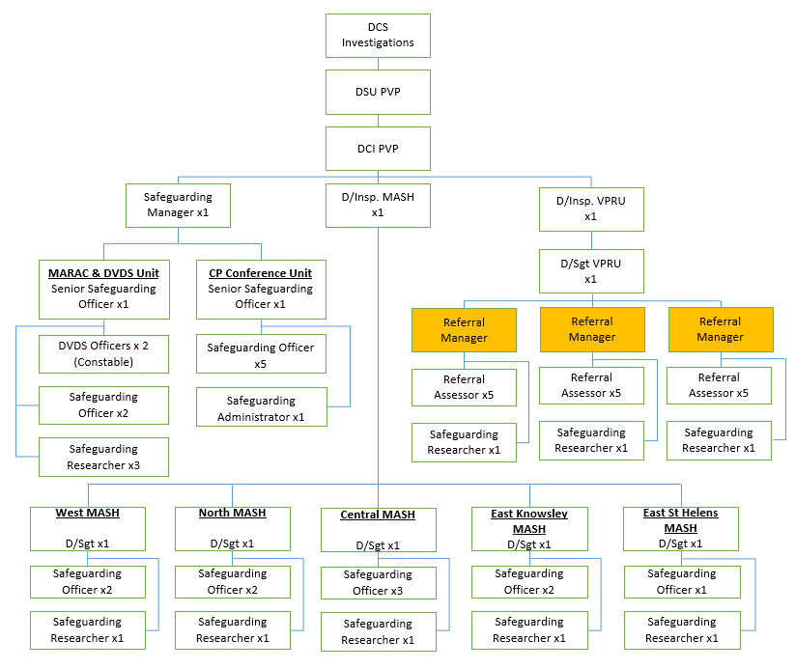

10. AGREEMENT OF QUESTIONNAIRE CONTENT:
(Please sign when completed)

POSTHOLDER’S NAME:
(Please print in block capitals)

POSTHOLDER’S SIGNATURE: Date: Extn

MANAGER’S NAME:
(Please print in block capitals)

MANAGER’S SIGNATURE: Date: Extn

