

JOB DESCRIPTION QUESTIONNAIRE (J.D.Q.)

DIRECTORATE: Resources
STRAND/DEPT: Finance
SECTION:
JOB TITLE: Head of Finance & Procurement
REPORTS TO: Director of Resources
CURRENT RANK/GRADE: Grade L
DATE: June 2026

- JOB PURPOSE:
To provide a strategic finance lead and provision of a professional finance and procurement service on behalf of the Force and the Police Crime
Commissioner (PCC) including acting as the Force Section 151 Officer under the terms of the Local Government Act 1972.To drive the continued improvement of finance and procurement services across the Force including processes, financial and procurement understanding and resource utilisation.

2. PRINCIPAL ACCOUNTABILITIES:
  - Lead and direct the Finance and Procurement Department including setting strategic direction and integrating the finance and procurement service with the overall Force and PCC objectives. This will require an understanding of National Policing issues and Force-wide strategies, to ensure Force priorities are appropriately matched with financial and procurement resources.

  - Negotiate and manage service level agreements with devolved budget holders for the provision of a professional budget management service, including the development and monitoring of appropriate performance measures.

  - Advise Chief Officers, PCC, Treasurer and officers on issues related to finance and procurement including high level professional and strategic matters. This will include drafting, advising and guidance upon the mid-term financial plan including the likely outcome and impact of future developments and changes and the impact of future funding levels.

  - Act as the Force lead on the annual budget preparation exercise, setting out budget construction strategy and guidance, assessing the impact of funding announcements and inflationary pressures and in conjunction with the Treasurer and Director of Resources drafting reports, presentations and briefings.

  - Act as the Force lead on the implementation of the Force Procurement Strategy, supporting the Force to achieve value for money whilst also ensuring compliance with internal and external regulations.

  - Deputise for the Director of Resources at Chief Officer and PCC meetings representing all Departments across the Resources portfolio. To represent the Force at external meetings and events either in the capacity of existing role or whilst acting as Deputy for the Chief Officer.

  - Prepare and present reports, presentations and briefings on finance and procurement related issues to PCC, Chief Officer, other Force and external meetings.

  - To act as Chief Financial Officer in compliance with Section 151 of the Local Government Act 1972. This will involve having oversight of Force financial decision making, monitoring the overall performance of the Force budget throughout the year, reporting on budget performance and challenging budget performance through regular meetings and with Chief Officers, to ensure best use of Force resources.

  - Report on compliance with Force Standing orders and cashable / non-cashable efficiencies in relation to procurement.

  - Oversee the proper maintenance of accounting records throughout the year and the production of the Annual Statutory Statement of Accounts. To ensure that legal requirements are met in this regard and that issues raised by the External Auditor are suitably actioned.

  - Be accountable for all Health and Safety issues, including risk assessment, pertaining to the post holder’s area of responsibility in order to fulfil the statutory obligations of the Health and Safety at Work Act 1974.

3(a) KNOWLEDGE AND EXPERIENCE:

Fully qualified CCAB Accountant, and educated to degree level.

Extensive (typically 3+ years) post-qualification experience of working within a demanding leadership role for a large and complex organisation.

Knowledge of all areas covered within the Resources Portfolio – Estates, Information Systems, Procurement, Vehicle Fleet – including specific issues within the Force, and also general trends within these business areas; to enable the post-holder to effectively deputise for the Director of Resources.

Detailed understanding of Force-level and National financial issues, to ensure that the post-holder can effectively deputise for the Director of Resources and ensure that financial resources are appropriately applied.

Senior level management skills with extensive experience of managing and adapting to change to facilitate a continually improving service; and engender an environment of service improvement.

Extensive experience of working under pressure to consistently meet key targets and objectives within deadlines producing work of a consistently high standard; and prioritisation of the many and various demands of a strategic role within a large organisation.

Significant experience of senior level leadership, with strong abilities in the areas of determining clear and consistent focus on key areas, and providing motivation for staff to perform towards these goals, to ensure the achievement of Force objectives and priorities.

3(b) No Police powers required

4. RELATIONSHIPS:

- Supervisory responsibilities:

Direct responsibility for the management of the Head of Financial
Operations, Head of Finance Business Partnering, Financial Systems
Accountant, Project Accountants and the Force Procurement and Contracts Manager; with indirect supervisory responsibility for the remaining staff within the Financial Operations, Operational Support Financial Transaction and Procurement Teams.
When deputising for the Head of Resources the post-holder will be expected to work with the department Heads of Corporate Assets and Information Communication Technology.

- Supervision Received:

Directly accountable to ACC Resources

(c) Other Contacts:

- Within Merseyside Police:

Regular contact with Chief Officers, Strand Leads, Heads of Department and Senior Managers in order to facilitate an effective service provision for the Force

- Outside Merseyside Police:
Regular contact with PCC, Home Office, NPCC, HMIC, NPIA, CIPFA, Bluelight Commercial and other Police Forces at senior strategic management level, to enable the Force to achieve it's primary objectives

5. CONTEXT:

- Operating Environment:

Postholder works within the Force flexible working hours scheme.

- Framework and Boundaries:

Ensures the Force's adherence to Financial Regulations, Force financial instructions and accounting standards, and statutory legislation, in order to meet operational needs.

(c) Organisation:

Head of Financial Operations - Responsible for managing and reporting upon the total Force budget as well as maintaining the Authority’s statutory financial accounts.

Financial Systems Accountant - To manage and support the day-to-day operation and ongoing development of the Force financial systems

Project Accountants - To provide a full range of financial management support services to the Force, focusing particularly on reviews and initiatives that support Chief Officers in ensuring the Force is able to operate efficiently within the overall financial constraints of the budget and enable decisions to be made based on sound financial techniques and professional advice.

Head of Finance Business Partners - To be responsible for managing a team of professionally qualified Accountants to ensure the delivery of a consistent and relevant level of financial support to Budget Holders across the Force. To take the lead on all Management Accounting matters and deputise for the Head of Finance when required.

Procurement & Contracts Manager - To be responsible for the management of the Force Procurement Section. Being instrumental in developing and implementing Force procurement strategies, ecommerce solutions and associated procedures and initiatives.

6. DIMENSIONS:

Financial:

Direct responsibility for the Finance and Procurement budget of £1.5m, with overarching responsibility to provide advice and guidance for the utilisation of the Forcewide budget of c.£500m

Staff:

6 direct reports; with 38 staff working within the areas under the postholder's control.

Other:
N/A

7. JOB CHALLENGES:

To build and manage a number of high level relationships with stakeholders positioned both inside and outside the Force

To engender within the daily operating practice of the Finance and Procurement Department an environment that embraces change and a drive towards building a constantly evolving and improving service to the Force

To act as a deputy for the Head of Resources, when required, across the entire Resources Portfolio in dealing with high level stakeholders positioned inside and outside the Force

8. ADDITIONAL INFORMATION:

9. VETTING LEVEL / POLITICALLY RESTRICTED :

This is a Politically Restricted post and requires Management Vetting (MV)

10. ORGANISATIONAL STRUCTURE:

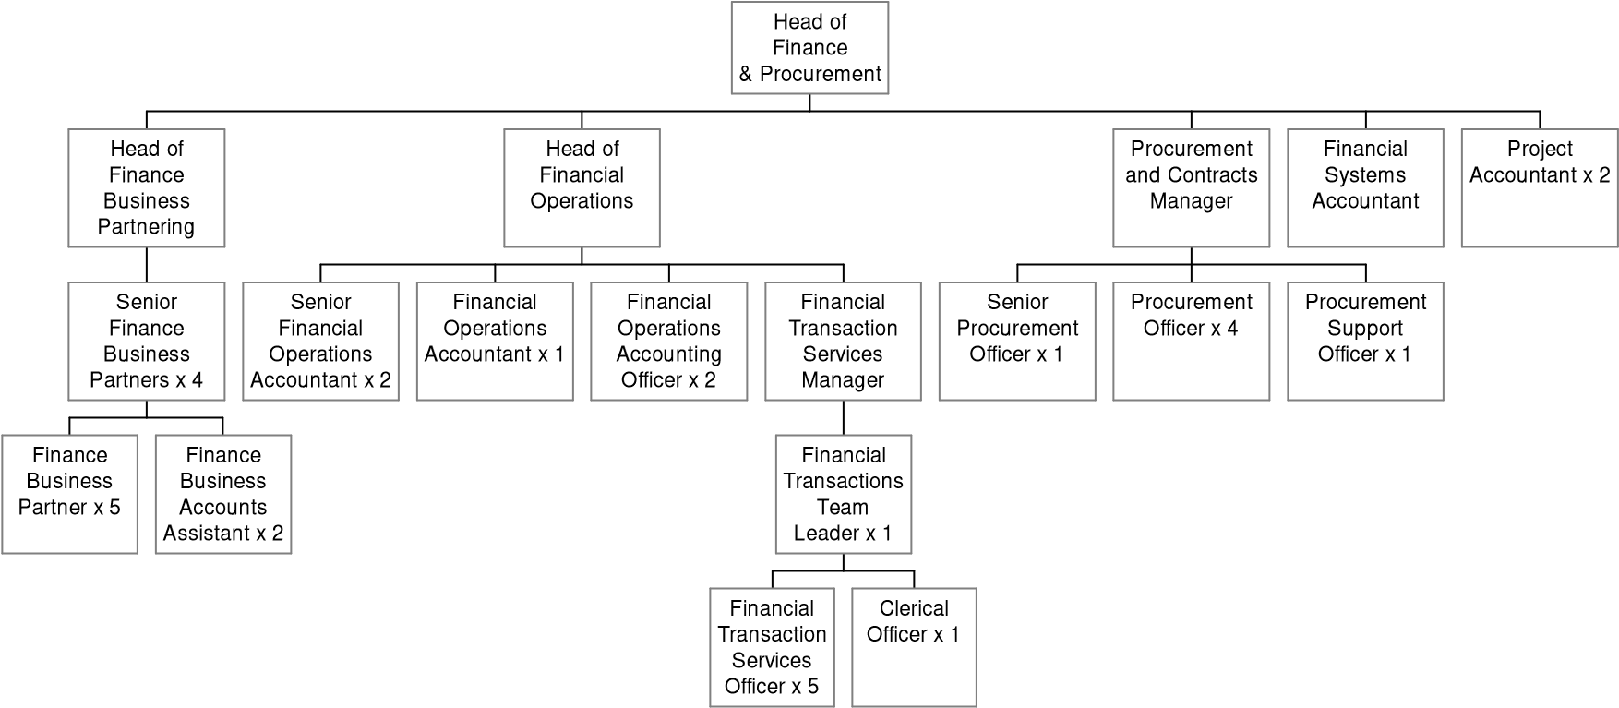

11. AGREEMENT OF QUESTIONNAIRE CONTENT:
(Please sign when completed)

POSTHOLDER’S NAME:
(Please print in block capitals)

POSTHOLDER’S SIGNATURE: Date: Extn

MANAGER’S NAME:
(Please print in block capitals)

MANAGER’S SIGNATURE: Date: Extn

